Experiment 11

11.1.1. Sum of digits of a number:

Algorithm:
Step 1: Start
Step 2: Read an integer num from the user
Step 3: Initialize a variable sum to 0
Step 4: Repeat while num > 0:
Find the last digit of the number
i = num % 10
Add the digit to sum
sum = sum + i
Remove the last digit from the number
num = num // 10
Step 5: After the loop ends, print the value of sum
Step 6: Stop

Flowchart:
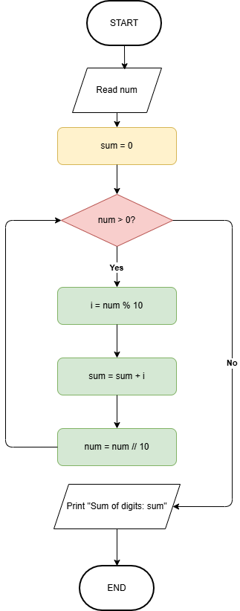

Execution:
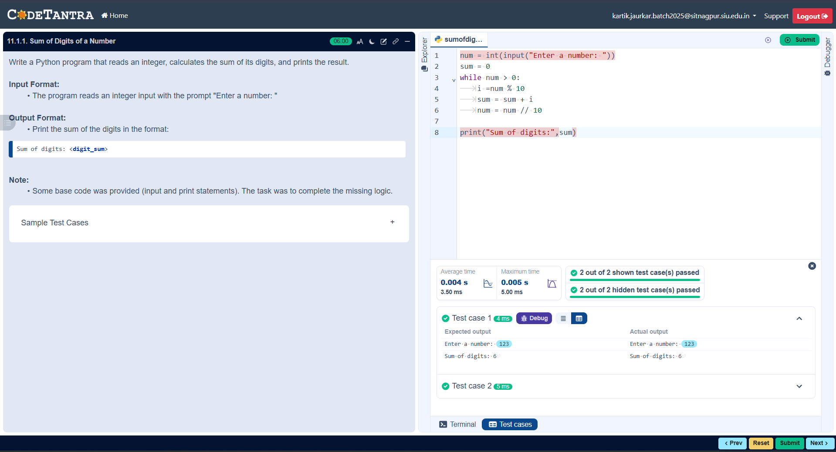

11.1.2 Sum of digits using recursion:

Algorithm:
Step 1: Start
Step 2: Define a function sum_of_digits_recursive(n)
Step 3: Check if n == 0 (base case):
- If true, return 0
Step 4: Else (recursive case):
- Find the last digit: n % 10
- Call the function again with remaining number: n // 10
- Return the sum:
(n % 10) + sum_of_digits_recursive(n // 10)
Step 5: Read an integer input number
Step 6: Call the function sum_of_digits_recursive(number) and store result in result
Step 7: Print the result
Step 8: Stop

Flowchart:
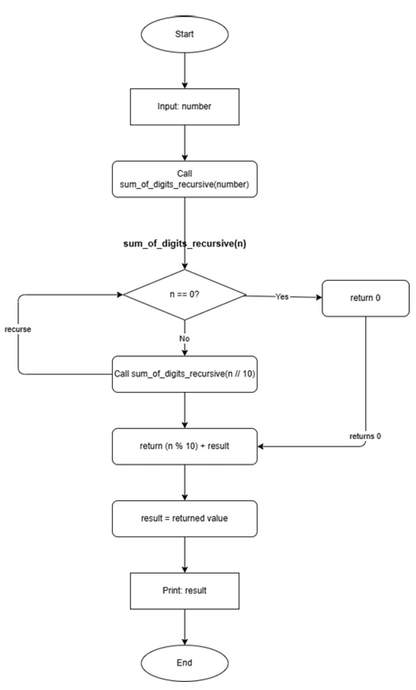

Execution:
